Children First Family Literacy GED
Summer 2020 Virtual Session
June 1st to August 5th, 2020
(10-Week Session)

Monday, June 1st – First day of virtual summer session
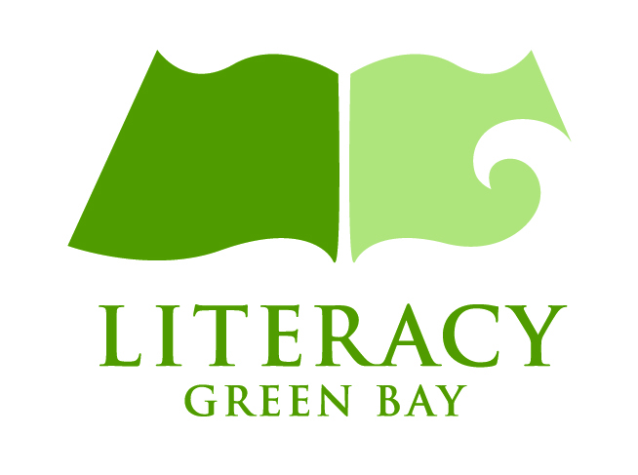
Wednesday, August 5th – Last day of virtual summer session

Classes to be held virtually (online) during the times outlined below:

Monday/Wednesday
(A.M. GED Class) 9:00-11:30am

Monday/Wednesday
(P.M. GED Class) 5:00-7:30pm

Eligibility Requirements
- Parent must be 18 ½ years of age to enroll in GED coursework
- Parent must have at least one child age 10 or under
- Parent must test at an appropriate reading level for GED instruction

Technology Needed to Participate Successfully
- Laptop or Desktop computer with Internet Access
- Microphone and Webcam

Registration/Testing
- Parent will need to complete a GEDReady Reading assessment (online) and score at an appropriate level
- Parent will complete an orientation process (online)
- For more information, contact Kelly Severson – Family Literacy Program Manager
At Literacy Green Bay 435-2474 ext.108

